

BIRTHDAY RATES

$24.99/Person includes SEMI Auto gun package with 100 paintballs

gun packages includes mask, co2 tank, and barrel plug
(Upgrade to theEnemy Gun and Unlimited Nitrogen fills for $5/person)
(Upgrade to Electronic Gun and Unlimited Nitrogen fills for $10/person)

Birthday Party Reservation Policy
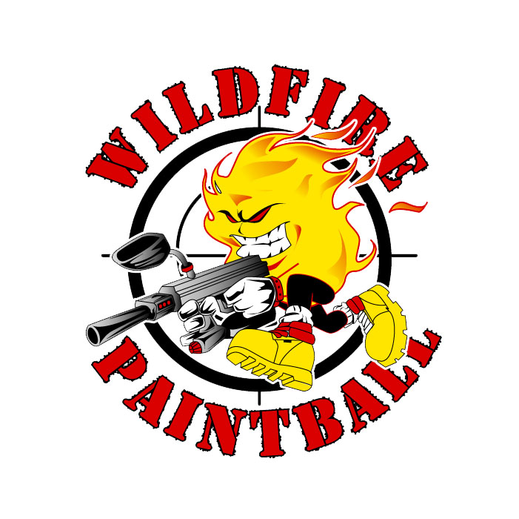
- Pricing is based on a group of 6 or more with advance reservations.
- A non-refundable deposit of $10 per person is required 5 days before play date.
- Deposit is to guarantee spots and equipment.
- If the minimum number of players do not show the group will charged the full rate for each no show. If a player no shows no one else will receive their paintballs.
- Rescheduling can be done only once and must be done 48 hours before scheduled play date.
- All players must sign waiver in order to play (players under age 18 must have adult signature).
- Group pricing is not good with any other promotions, offers or discounts.
- All paint must be purchased from Wildfire Paintball Games.
- No verbal agreement will be honored. If a booking agent promised something, it must be in writing and approved by the company supervisor to be valid.
- We reserve the right to modify our policies at any time and to correct any typographical errors.

Wildfire Paintball Games

3725 US Hwy 78
Suite C
Snellville GA 30039

